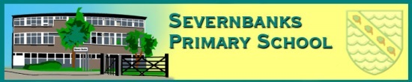


Starlets
Nursery and Pre-School
Prospectus
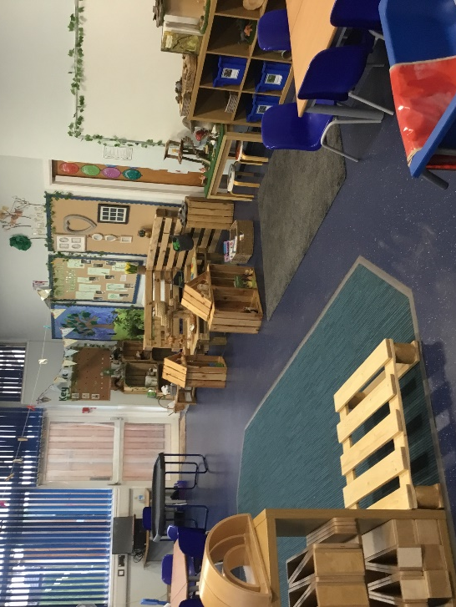
Severnbanks Primary School
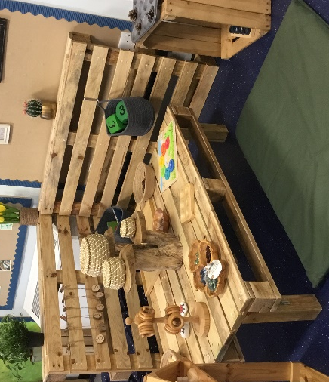
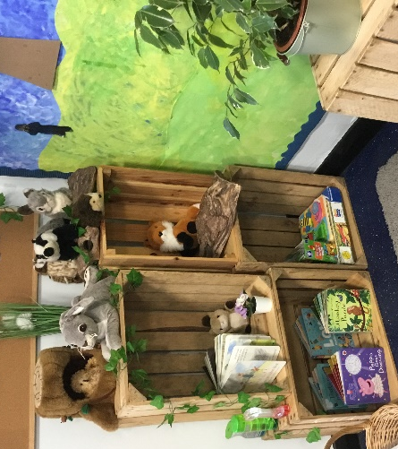

Severnbanks Primary School
Naas Lane, Lydney, Gloucestershire, GL15 5AU

Headteacher: Mrs Natasha Bradley
Email: admin@severnbanks.gloucs.sch.uk
Website: http://www.severnbanksprimaryschool.co.uk
Telephone: 01594 842789

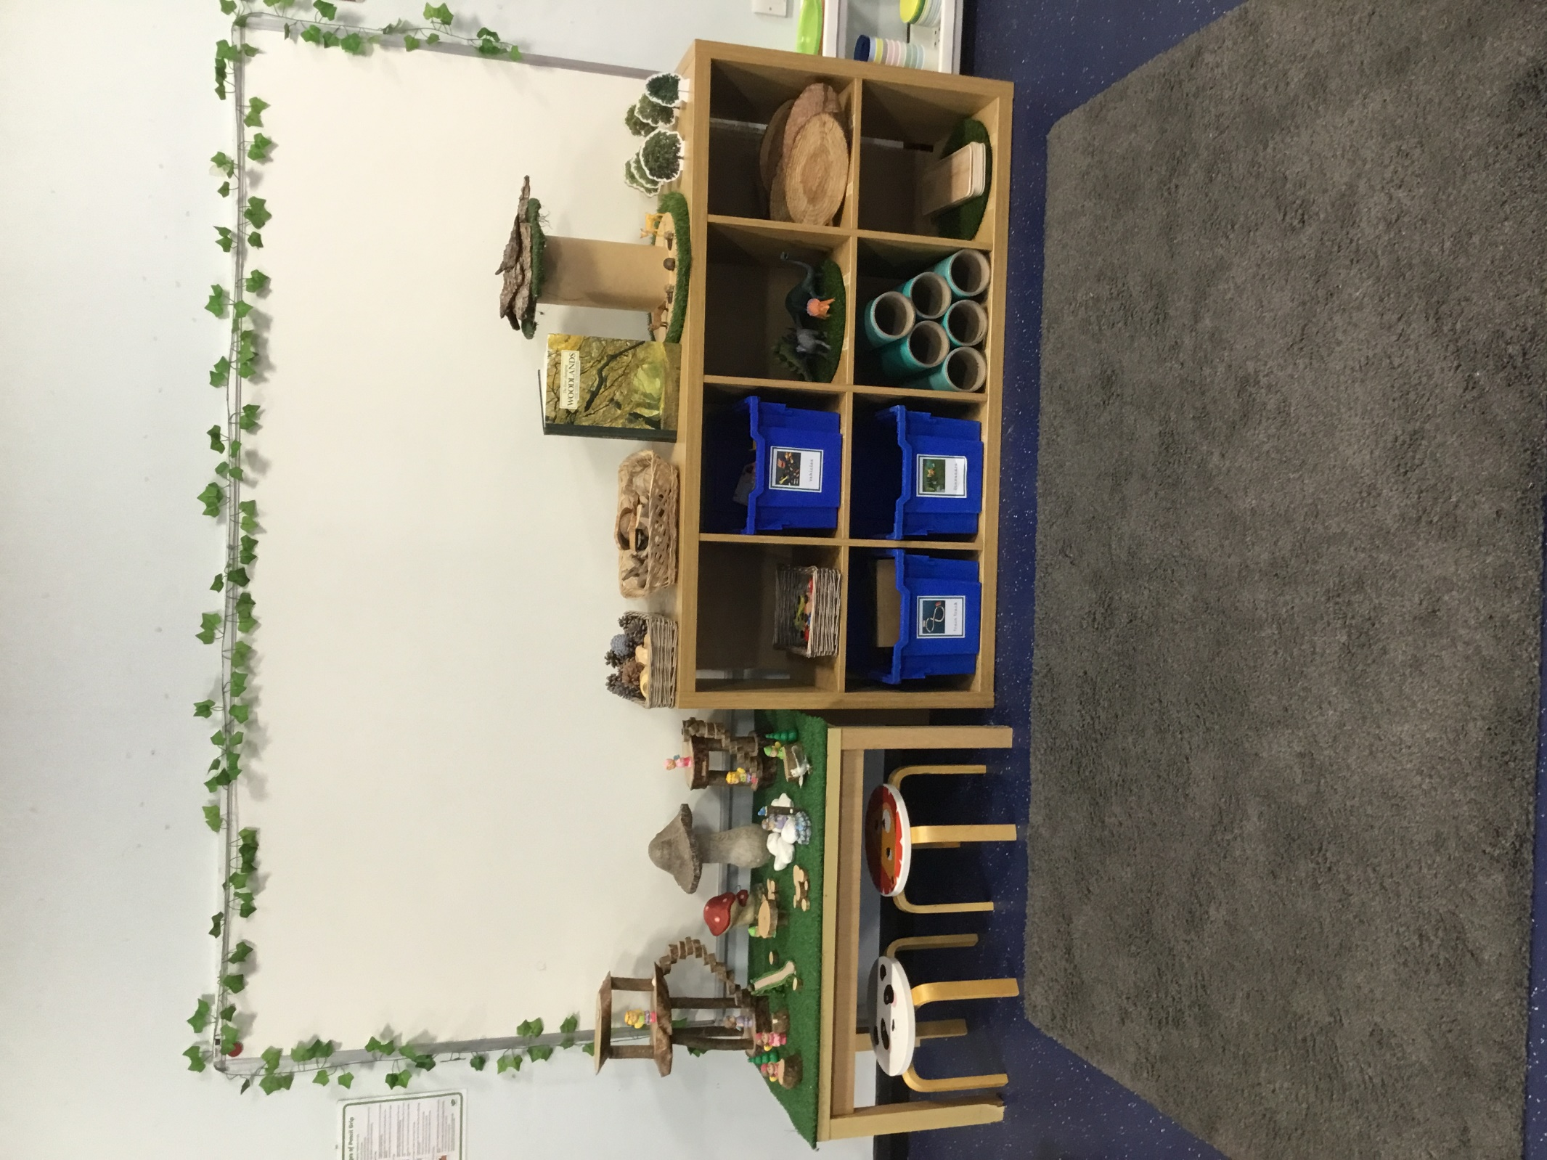
Meet the Team

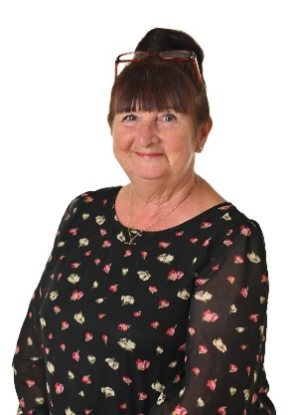
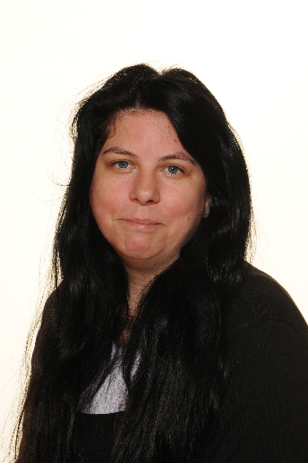

Mrs Sam Pit Mrs Annie Martin
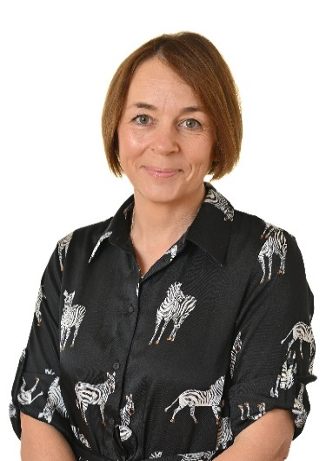
Nursery lead HLTA Nursery Key worker

Miss Sarah Powell
EYFS Lead teacher


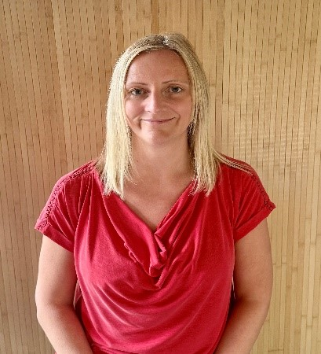

Head Teacher SENDCO Pastoral support
Mrs N Bradley Mrs Shona Howell Mrs Jackie Challenger

Severnbanks Primary School
Where Stars Shine

Welcome!
We would like to welcome you to Severnbanks Starlets, our Early Years provision for children from three years of age. We are situated in Severnbanks Primary School and form part of the Foundation Stage (EYFS) setting.
Our Aim….
- To provide high quality care and education for children below statutory school age.
- To work in partnership with parents to help children learn and develop.
- To provide a caring, safe, secure and stimulating environment that promotes learning through play.
- To work with a framework which ensures equality of opportunity for all children and families.
Children
We put children at the very heart of our provision. Our prime focus when your child joins our setting will be to help them achieve a high level of emotional, behavioural and school wellbeing, we know these are key factors in enabling children to be more engaged and make better progress in their learning as they move through their primary school years and beyond. On entry to Starlets your child will be assigned a Key Worker. Your Child’s Key Worker provides familiarity, pattern and predictability and will help your child understand who they are and what they can do.
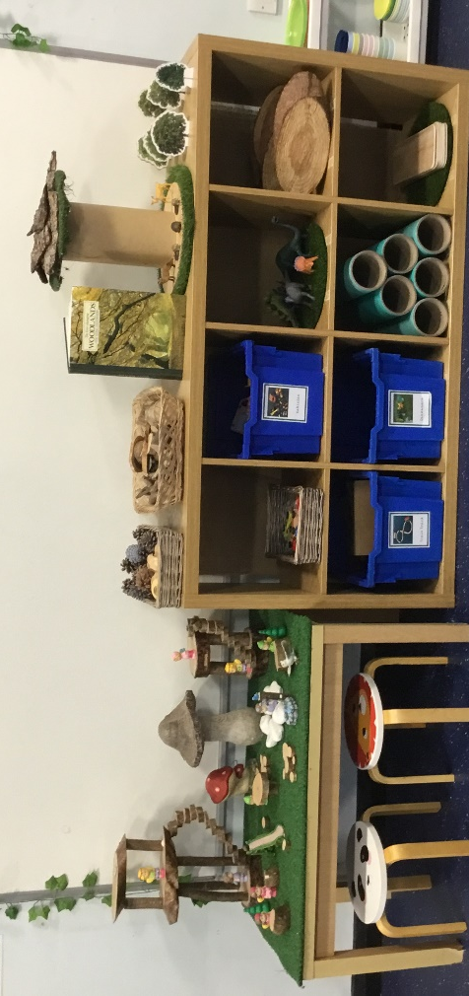
Children learn by playing, observing and being with others. All EYFS staff will facilitate learning opportunities through play individually and with others. Your child will also be taught through adult directed activities. Children concentrate and learn more effectively if not under stress or pressure, so having a familiar adult who is attentive and knows your child well will support their development.
Staff interact with the children by encouraging, facilitating and supporting them whilst they have fun, learn through play, talk about their experiences and share their enjoyment with others, enabling your child to grow in confidence and independence.

Starlets Curriculum
The Early Years Foundation Stage Framework (EYFS) is a document which sets standards for the learning, development and care of children from birth to 5 years old. All schools and Ofsted-registered early years providers must follow the EYFS, including childminders, preschools, nurseries and school reception classes.
Our nursery sessions are carefully planned, resourced and are a balance of adult led and child experiences. Adults are highly skilled and facilitate learning, knowing when to take an active role, be an audience, play partner, encourage or step back to allow children to drive the learning forward. The children have access to an enabling environment where they will be encouraged to explore and engage in activities that will develop all areas of their understanding.

Children enjoy a timetabled session in our beautiful Forest School area, where they are able to engage with the natural world around them through carefully planned activities. There is also plenty of time given for them to explore and discover through their own child initiated play. All children are provided with wetsuits for this session.
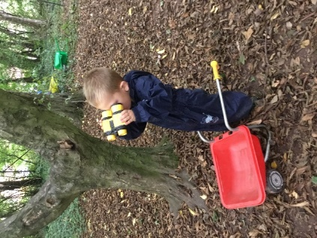
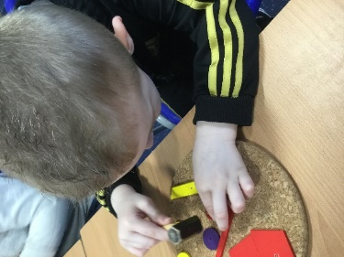
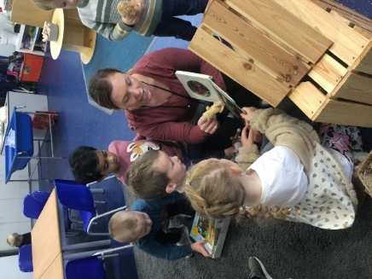

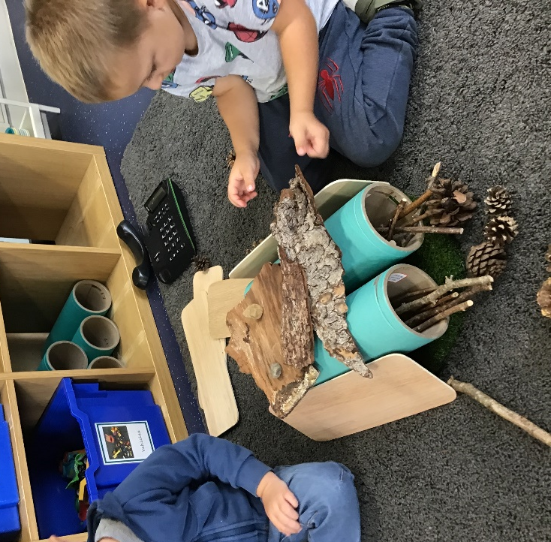

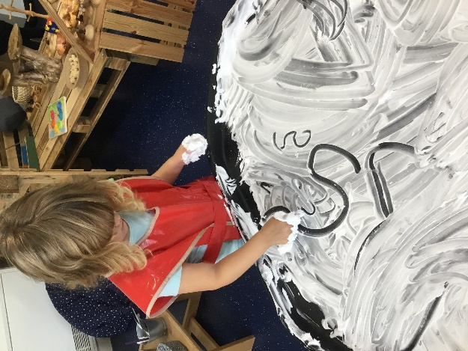
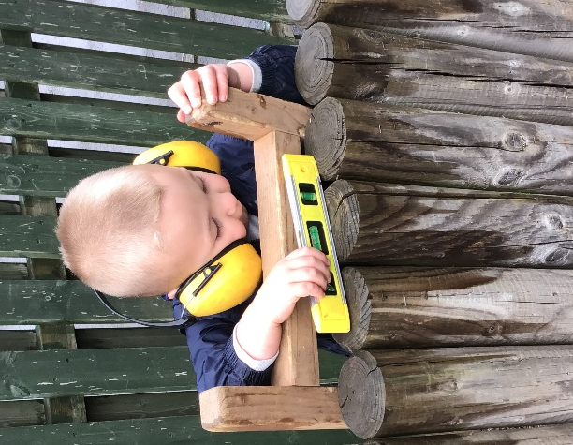

Areas of learning – as outlined in the EYFS Framework 2021
Communication and Language, Personal, Social, Emotional Development, Physical Development, Literacy, Maths, Understanding the World, Expressive arts and design

Sessions
Sessions run from 8:45 – 12pm (no lunch) or 12pm – 3:15 (with lunch).

Requirements for sessions
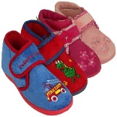
Children will need to wear comfortable clothing suited to the weather conditions. As we spend a lot of time outdoors please ensure this includes sun hat, gloves, scarf, waterproof coat. We do have a small amount of spare clothes, but we would be incredibly grateful if you could also provide a complete change of clothes in the event of a toilet or play accident. Please let nursery staff know if you would like clothes returned at the end of each session, otherwise they can be safely stored on your child’s individual peg.
Shoeless Learning
“No shoes is good news”
Here at Severnbanks we have been shoeless learning in EYFS for many years. We strongly believe this approach has a positive impact on your child’s well-being and ability to learn. Your child will wear their school shoes to and from school and during lunch time play. Slippers will be worn when children are accessing indoor provision. Please ensure the slippers you provide for your child have a hard sole and fit well (no novelty slippers). Slippers will be kept in school and returned for washing/replacing at the end of each term.

Your child will also require a pair of wellies for outside play.

Please ensure all items of clothing and footwear
are labelled.

Staying for lunch
If your child is staying all day or attending an afternoon session which includes lunchtime you will need to provide a packed lunchbox, alternatively hot school meals are available at a cost of £2.71 per day. Payments are made via Parent Pay and menus are available from the school office.
Drop off and Home time
Starlets gate is situated on the footpath leading towards the main school reception. A member of staff will be waiting to welcome your child at the nursery classroom door. The door is opened at 8.45am for morning session and 12pm for afternoon sessions. Pick up will also take place via this gate. Please ensure you have completed the paperwork stating who will collect your child from school. We will only allow your child to be collected by someone you have authorised when you register your child.

Illness/Absence
If your child has a temperature, is sick or has diarrhoea, please do not send them in until a clear 48 hours after the symptoms have stopped. If your child is absent for any reason, please telephone the office on the day before 10am
01594 842789 or contact us through Parent Mail
Safeguarding
We aim to create an environment which promotes and safeguards the welfare of children. We have a duty of care to refer any allegation, complaint or concern received relating to a child to Gloucestershire Safeguarding Children’s Board for advice.
Policy Statement
It is our intention to make our setting accessible to children and families from all sections of the local community. We aim to ensure that all sections of our community have access to the setting through open, fair and clearly communicated procedures. We will not discriminate against children in nappies, and will work with parents/carers to toilet train children

Hours, funding and extra paid sessions.
Starlets welcome children from the term of their 3rd birthday if they are in receipt of childcare funding or if the parent/carer wishes to pay for their sessions
If you are an eligible working parent in England, you can now apply for:
- 15 hours childcare for your child aged 9 months old until they turn 3 years old
- 30 hours childcare for your 3 or 4 year old

You will need to apply by:
31st August to use your hours from 1st September.
31st December to use your hours from 1st January
31st March to use your hours from 1st April
To do so, visit gov.uk to create your childcare account and get your code and then share it with your childcare provider. To continue receiving the government support, you will need to reconfirm your details every 3 months on your gov.uk childcare account.
If you already use 15 hours for your 2-year-old and they then turn 3 years old and become eligible for 30 hours, the code for 15 hours will be the same as the one for 30 hours. You can reconfirm as normal when you are able to on your childcare account on gov.uk, and the code will be valid for the 30 hours offer.
This comes alongside other already existing government childcare support, including 30 hours childcare for 3 and 4 year olds, Tax-Free Childcare and Universal Credit Childcare. You might be able to use more than one offer together to help with your childcare costs.
If my child turns 3 years old between | I can access their funded hours from
1 January to 31 March | Term starting on or after 1 April
1 April to 31 August | Term starting on or after 1 September
1 September to 31 December | Term starting on or after 1 January

Additional paid hours
Your child can do more sessions than their free entitlement and these will be charged at the hourly rate of £5.33 per hour.
Notice of changes
If your child is leaving Severnbanks Starlets, we will require a full term notice.
Nursery Fees and Payments.
Nursery fees will be added to your account on our online payment system. You will get a notification of payment amount and reminders if unpaid. Weekly payments can be accepted but must be paid in advance.
Fees unpaid and arrears
We hope that you appreciate that we are unable to allow fees to slip into arrears. Failure to pay the fees on time will result in the loss of your child’s place and your child will be refused entry until the account is cleared and the forthcoming week paid.
Fees during absence
If your child is booked in for a session and is absent due to sickness or holiday, the full fee must be paid for the place.

Induction Session
We know that starting nursery is a big step for you and your child. To support this transition, we offer every child an induction session in the term before they start with us.
Further information
Should you require any further information or if you would like to book a visit to view our nursery, please phone the school office on 01594 842789

