
Year 1 History Knowledge Organiser – Dinosaurs

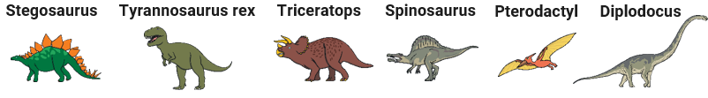
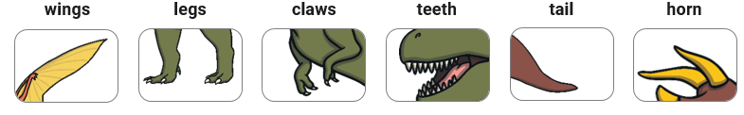
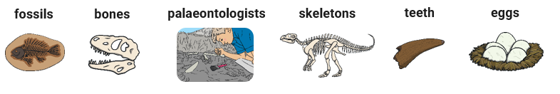

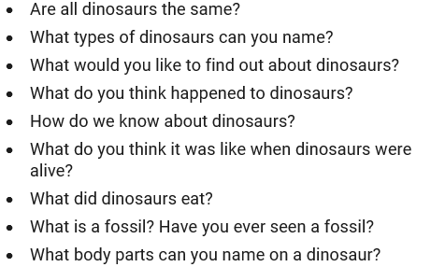
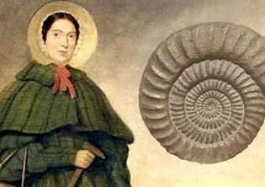
Who is this and why do we remember her?

