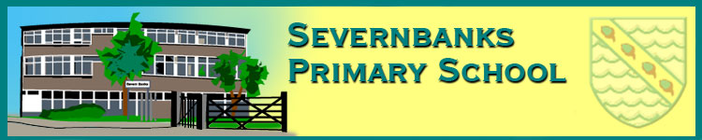
Year 5 Curriculum Overview 2025-2026
 | Term 1 | Term 2 | Term3 | Term 4 | Term 5 | Term 6
Value | Resilience | Resilience | Respect | Respect | Kindness | Kindness
Focus | History – Who were the Anglo Saxons and Vikings? | Science – Solar System | Geography – Mountains – Life in the Alps | Geography – Why do oceans matter? | History - Mayans | Geography –  Desert – Would you like to live in the Mojave Desert?
TEXTS | Anglo Saxon Boy – Tony Bradman  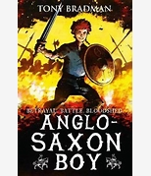 | Curiosity – the story of a Mars Rover – Markus Motum  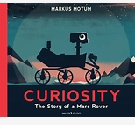 | King of the Cloud Forest by Michael Morpurgo  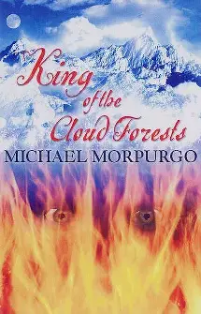 | Clockwork – Phillip Pullman (QUALITY TEXT – not linked to Geography topic)  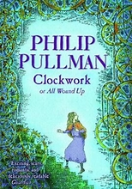 | Oh Maya Gods by Maz Evans  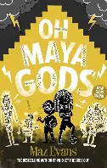 | Holes by Louis Sachar  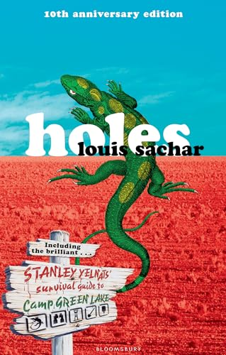
Maths  White Rose | Place Value  Addition and Subtraction  Multiplication and Division A | Multiplication and Division A  Fractions A | Multiplication and Division B  Fractions B | Decimals and Percentage  Perimeter and Area  Statistics | Shape  Position and Direction  Decimals | Negative Numbers  Converting Units  Volume
Science: KAPOW | MATERIALS: Mixtures and separation | Forces and space: Earth and Space | MATERIALS: Properties and changes | Living Things: Life cycles and reproduction | Forces and space: Unbalanced forces | Animals: Human timeline  Making connections: Does the size of an asteroid affect the diameter of its impact crater?
History: No scheme | TEACH AUTUMN I  Anglo Saxons and Vikings |  |  | TEACH SUMMER I  The Maya
Geography: KAPOW |  |  | Mountains – Life in the Alps | Why do oceans matter? |  | Desert – Would you like to live in the Mojave Desert?
Computing: Computing NCCE (Teach Computing) | Systems and Searching | Creating Media – Video Production | Programming A | Data and Information – Flat File Databases | Creating Media – Vector Graphics | Programming B
PSHE: - Jigsaw | Being Me in My World | Celebrating Difference | Dreams and Goals | Healthy Me | Relationships | Changing Me
DT: Kapow | Mechanical systems: Pop-up book | Electrical systems: Doodlers | Digital world: Monitoring devices | Structure: Bridges | Textiles: Stuffed toys | Cooking and nutrition: Developing a recipe
ART: Kapow | Painting and mixed media: Portraits  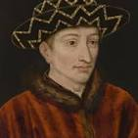  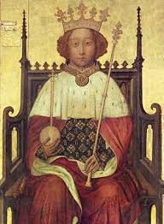 | Drawing: Depth, emotion and movement  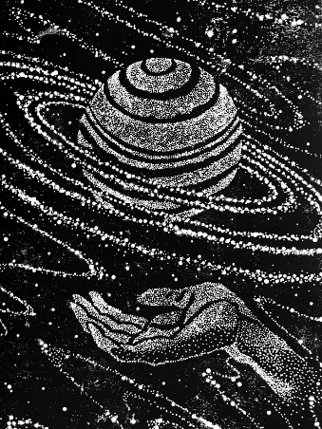  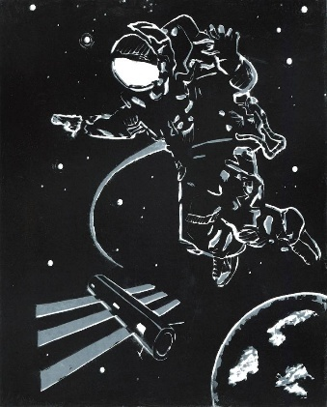 |  | Sculpture and 3D: Interactive installation  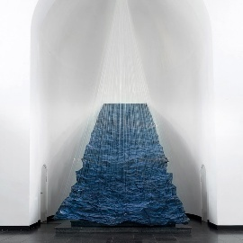  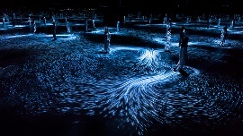  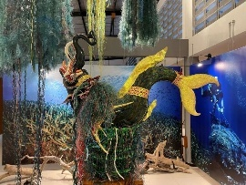 |  | Craft and design: Architecture  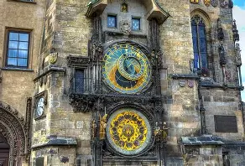  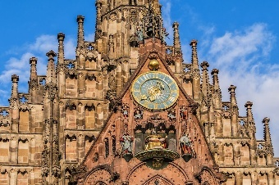
RE: RE Discovery | How Far Would a Sikh go for their Religion? | Is the Christmas story true? | Are Sikh stories important today? | How significant is it for Christians to believe God intended Jesus to die? | What is the best way for a Sikh to show commitment to God? | What is the best way for a Christian to show commitment to God?
PE: Get Set PE  Daily Mile – Tue and Thur in Acer | Netball | Football | Dance | Outdoor Adventurous Activity | Cricket | Tennis
Music: Kapow | Composition notation (Ancient Egypt)  TBAT represent the features of a piece of music using graphic notation, and colours, justifying their choices with reference to musical vocabulary.  TBAT Develop confidence in using detailed musical vocabulary (related to the inter-related dimensions of music) to discuss and evaluate their own and others’ work.  TBAT Compose a detailed piece of music from a given stimulus with voices, bodies and instruments (Remix, Colours, Stories, Drama). Improvising coherently within a given style.  TBAT Use staff notation to record rhythms and melodies.  TBAT Select discuss and refine musical choices both alone and with others, using musical vocabulary with confidence.  TBAT Suggest and demonstrate improvements to own and others’ work.  TBAT Sing songs in two or more parts, in a variety of musical styles from memory, with accuracy, fluency, control and expression.  TBAT Work as a group to perform a piece of music, adjusting dynamics and pitch according to a graphic score, keeping in time with others and communicating with the group.  TBAT Combine rhythmic patterns (ostinato) into a multi-layered composition using all the inter-related dimensions of music to add musical interest. | Blues  TBAT Name three key features of Blues music.  TBAT Sing in tune, using vocal expression to convey meaning.  TBAT Explain what a chord is and play the chord of C sixteen times.  TBAT Play the twelve bar blues correctly.  TBAT Play the notes of the Blues scale in the correct order, ascending and descending.  TBAT Play a selection of Blues scale notes out of order in their own improvisation. | South and West Africa  TBAT Sing using the correct pronunciation and with increasing confidence.  TBAT Play a chord with two notes, remaining in time.  TBAT Maintain their part in a performance with accuracy.  TBAT Play the more complicated rhythms in time and with rests.  TBAT Create an eight beat break and play this in the correct place. | Compositions for the festival of colour  TBAT Suggest a colour to match a piece of music.  TBAT Create a graphic score and describe how this matches the general structure of a piece of music.  TBAT Create a vocal composition in response to a picture and justify their choices using musical terms.  TBAT Create a vocal composition response to a colour.  TBAT Record their compositins in written form.  TBAT Work as a group to perform a piece of music. | Looping and Remixing  TBAT Perform a looped body percussion rhythm; keeping in time with their group.  TBAT Use loops to create a whole piece of music, ensuring that the different aspects of music work together.  TBAT Choose a suitable fragment of music and be able to play it along to the backbeat  TBAT Perform a piece with some structure and two different loops. | Musical Theatre  TBAT Explain what musical theatre is and be able to recall at least three features of this kind of music.  TBAT Categorise songs as action songs or character songs.  TBAT Select appropriate existing music for their scene to tell the story of a journey.  TBAT Perform in time with their groups, ensuring smooth transitions between spoken dialogue, singing and dancing.
MFL: Language Angels | As-Tu un Animal? (Have you a pet?) | Les Planetes  (The Planets) | Quelle Est La Date Aujourd’hui?  (What is the date today?) | Les Vêtements  (Clothes) | Quel Temps Fait-Il?  (What is the weather?) | Les Habitats  (Habitats)
Curiuosity Questions
What? | What is so important about the Anglo Saxons and Vikings?  What are the Anglo Saxons and Vikings similar and/or different? | What is the solar system? | What is it like to live in a mountainous area? | What do reversible and irreversilble mean? | What was life like in Mayan times? | What can you tell me about a desert climate?
Why? | Why did people invade Britain? | Why is there daylight and darkness? | Why do we not float on earth as we might in space? | Why do we need energy? | Why are they important? | What is the same/different between the Mojave desert and Lyndey?
When? | When did the Anglo Saxons and Vikings invade? | When did the solar system exist? | When is some snow too much snow? | When might we need to reverse a chemical change? | When did the Mayans live? | When was it built?
How? | How long ago did they live? | How far from the sun are each of the planets? | How are mountains formed? | How can we get the energy we need in an emvironmentally friendly way? | How have Mayans impacted the way we live today? | How hot is it in a desert environment? Are all deserts like the same?
Where? | Where in a chronology of history would the Anglo Saxons and Vikings appear? | Where is Mars? | Where are the Alps? | Where do fossil fuels come from? | Where did the Mayans live? | Where would you prefer to live?

