Phonics
Letter sounds | oa, oo, ar, or, ur, ow oi and ear
Blending | Read words containing all phonemes taught.
Segmenting | Write words, phrases and captions.
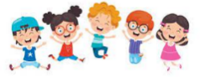  Common exception words | I to the no go into.  He, she, we, me, be, you, they all, are, my, her was.  Some, one, said, come, do, so, were, when

Journeys
Focus Texts
Whatever
Next
The
Train Ride
Reception Class – Curriculum Plan Summer 1
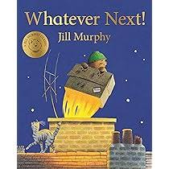
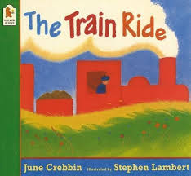
Key Events
W.B. 28th April – Road safety awareness week
Monday 5th May Early May Bank Holiday

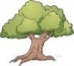
Understanding the World
Past and present; People, Culture and Communities; and The Natural World.
In RE this year our theme is ‘Story Time,’ we will be learning important values through stories from Christianity, Judaism and Islam. We will begin to understand what ‘The moral of the story’ means. The first story we will learn about is ‘The boy who cried wolf.’

In thinking about ‘Our world’ we will explore the natural process of light and dark. We will be looking at light sources and how shadows are created. We will continue to observe the changing seasons and discuss the changes we see as the weather gets warmer.

We will be learning about different types of transport including rockets. We will be finding out more about planet Earth, space and the planets in our solar system.

We will look closely at maps and begin to draw our own. We will be learning about different physical features and using vocabulary such as fields, orchards, wood and ocean.
Literacy
Reading
This term we will be encouraging the children to think more critically about what they have read or what is read to them. Children will be given the opportunity to read, labels, instructions, signs and envelopes.
Writing
This term the children will write;
A List of items to take to the moon
A postcard following their trip to the moon.
Repetitive phrases
What shall I see? What shall I see? as we look out of the window on our train journey.
Personal, Social and Emotional Development
Relationships
This term we will talk about our families and what it feels like to belong. We will find out how to make friends and what it means to feel lonely. We will think about friendships and how to stay friends. We will think about the impact of unkind words and actions and begin to understand how to resolve friendship issues. We will use strategies to help calm ourselves when we are angry and use the zones of regulation to manage our feelings.
We will find out how to be a good friend and look at the actions of what a good friend does.

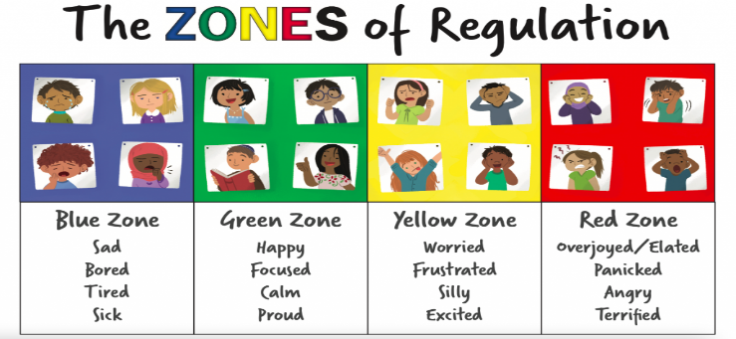

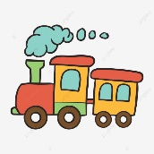


Communication and Language
We will be answering ‘why’ questions using our focus texts and when learning about transport and light and dark.
We will model and encourage well-formed sentences that convey thoughts and idea.

Communication and Language
Listening, attention and understanding. We will be asking the children to answer a greater range of questions beginning with who, why, when what, where and how. We will listen to more stories where children will be encouraged to engage without props or pictures.
Speaking The children will be encouraged to use well formed sentences to convey their thoughts, meaning and ideas. In discussions children will use talk to clarify their thinking, ideas and feelings and talk in detail about events. We will expect children to use tenses and plurals with greater
accuracy.

Maths
We will continue to practise recognising small amounts without the need to count them.
We will practise quick recall of doubles to 5 and begin to learn doubles for numbers 6-10.
We will continue to recall numbers that are one more and one less within numbers to ten and develop this understanding with numbers to 20.
Children will be given lots of opportunities to answer how many questions and know that the last number they say tells us how many are in the set.
We will practise strengthening our ability to say the number names to and back from 20 and from any number within the sequence.
We will be able to recognise numbers as odd or even.
We will explore and recall the composition of all numbers from 1 to 10
We will continue to develop our numeral knowledge from 0-20 and link with the matching amounts.
Physical Development
Yoga with Caroline every Tuesday – We will continue to develop our core strength, listening skills and knowledge of yoga poses.
This term our unit of study is DANCE
- Theme: head, shoulders, knees and toes
To explore different body parts and how they move.
- Theme: head, shoulders, knees and toes
To explore different body parts and how they move and remember and repeat actions.
- Theme: transport
To express and communicate ideas through movement exploring directions and levels.
- Theme: transport
To create movements and adapt and perform simple dance patterns.
- Theme: morning routine
To copy and repeat actions showing confidence and imagination.
- Theme: my journey to school
To move with control and co-ordination, linking, copying and repeating actions.
Expressive Art and Design
This term our music theme is ‘transport’ which links beautifully with our Journeys topic. The children will have the opportunity to use their voices, bodies and instruments to explore different types of transport, identifying and mimicking transport sounds. They will read a simple music sore and perform following musical notation.
The children will have the opportunity to build and construct with stickle bricks, Lego and Poly-M. We will be introducing simple wood working tools and discussing how to use hammers and hand drills safely.
Imaginary play will be developed though our hospital corner, complete with stethoscopes and bandages. The small world area of the classroom has been updated with different types of transport including construction and space exploration vehicles.
In art we will be looking at the work of Vincent Van Gough focusing on The Starry Night painted in 1889, as part of this topic we will experiment painting on different types of surfaces.

