What is HAF?  HAF is an activity programme that allows children and young people from reception to year 11 and eligible for free school meals to have access to activities and hot meals during school holidays.  (For children and young people who are eligible for benefits related free school meals.) |  | 3. Community Connectors  Our Community Connectors are Sarah and Mel.  We offer additional elements of support and guidance around transport, signposting and referring to other agencies and community support.  BarnardosHAF@barnardos.org.uk  Telephone: 01594 806876. |  | - HAF Information  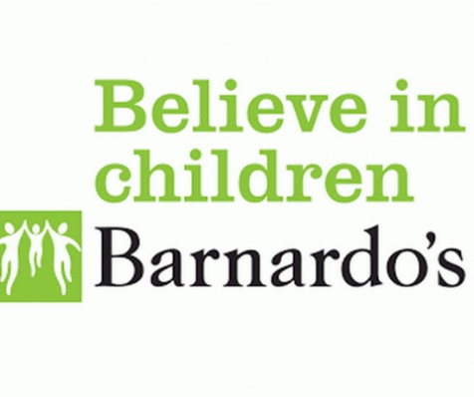  Holiday Activities and Food Programme
2. How Schools Play a Part
Schools will be able to sign families up who receive free school meals, then inform the Community Connector and we will do the rest.
https://gloucestershirecounty.coordinate.cloud/account/register

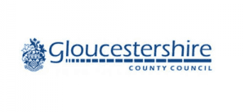  Sports Club Camps  4. How to book activities  - Get in touch with us  https://gloucestershirecounty.coordinate.cloud/account/register  - Come to one of our Children & Family Centre’s where staff can support at Hilltop, Latimer road, Cinderford, GL14 2QA or River, Naas Lane, Lydney, GL15 5AU |  | Family Fun Engineering  Arts & Crafts |  | Cinema  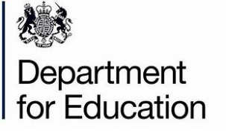  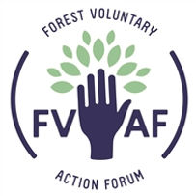
5. What are the benefits of HAF
HAF providers offer a safe environment for vulnerable children to be:
- Fed
- Active
- Entertained
- Included
- Gain new experiences
Cookery

