Thursday mornings from 9:30am-11:30am
Starting Thursday 11th January 2024 for 10 weeks
River Children Centre, Lydney.
Adult ACES Recovery Toolkit



Do you find relationship with family tricky?
Do you look at others and think what is wrong with me?
Do you feel like you’re going round in circles?
Are you fed up of feeling stuck?
Forest Location: TBC
Please book directly : Family Information Service on 01452 427362 Familyinfo@gloucestershire.gov.uk
Please call one of our children’s centres for more information
Becky @ Hilltop, Cinderford: 01594 827595
Or Claire @ River, Lydney: 01594 842589
Rockpool Adverse Childhood Experiences (ACES)
ACES are stressful events that occur in childhood which can negatively influence how individuals live their lives.
This programme aims to look at the impact of ACES on individuals and how this affects them and their children.
It supports parents to recognise and develop protective factors which help them mitigate the impact of ACES.
Practical methods are explored to develop the resilience for parent/carers and their children.
The course does not revisit the trauma but looks at how trauma effects our behaviour, activates triggers and influences our life choices.
Aims
• Create a safe space and feel comfortable to work towards recovery
• Protective factors and understanding ACES as well as toxic stress
• Promoting positive relationships with others including attachment
• Knowledge of parenting and child development

We aim to…
- Support better understanding of the impact that living with ACEs has had on you and your children.
- Help to develop strategies for building your resilience and your children.
- Increase understanding and implementation of healthy living skills.
- Have the tool to deal with the impact of ACEs and develop strategies to increase resilience and increase self-esteem.

If you answered YES to one or more these questions, why not join some like-minded people in breaking this cycle?

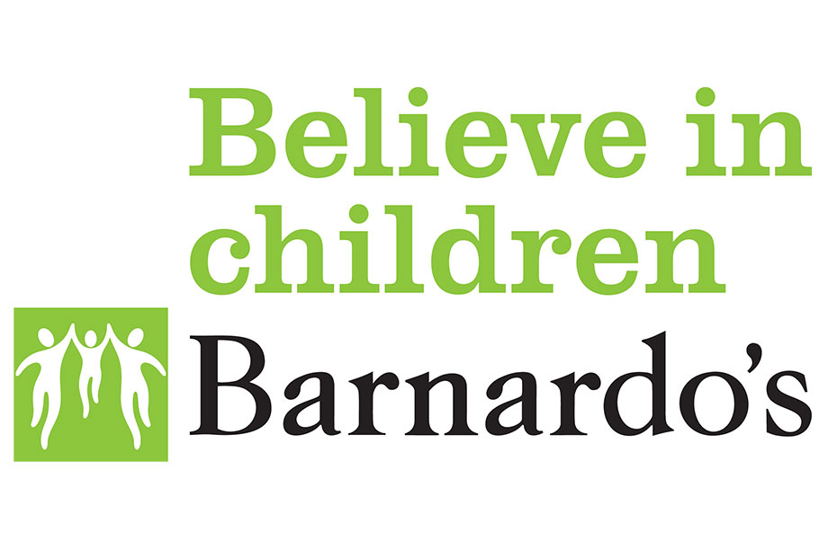

Forest Location: TBC
Please book directly : Family Information Service on 01452 427362 Familyinfo@gloucestershire.gov.uk
Please call one of our children’s centres for more information
Becky @ Hilltop, Cinderford: 01594 827595
Or Claire @ River, Lydney: 01594 842589
If you answered YES to one or more of these questions, why not join some like-minded people in breaking this cycle?

