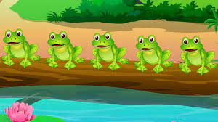
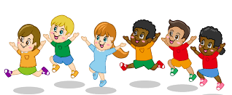


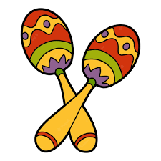
Personal, Social and Emotional Development
The first few weeks of the school term will be about getting to know each other and building confidence and trust. We will encourage the children to ‘use their words’ to let us know how they are feeling and make their needs known.
We will talk about and recognise feelings of sadness, happiness and worry.
We will be thinking about ourselves and how we each spend time with our families.
Children will be encouraged to develop independence in play and accessing resources.
We will be trying a wide variety of fruits and vegetables at snack time.

Physical Development
We have lots planned this term. We will be singing lots of action rhymes while we stretch out our arms and jump up and down. We will be using the scoot boards, trampettes, trikes and balance bikes. In the garden we will be able to use the large blocks and scaffold planks, wheelbarrows and spades.
Mathematics
We will be singing songs to help us learn how to say the number names in the correct order.
We will sing, the ants went marching one by one and one, and One potato, two potatoes with actions and pictures to help us count one object at a time.
We will be using the stories of The Little Red Hen and We’re going on a bear hunt to help us understand positional language.
At snack time we will be counting the number of spaces, plates and cups needed.

STARLETS AUTUMN TERM 1
Literacy
Our focus texts this term are Little Rabbit Foo Foo, The Little Red Hand and We’re going on a bear hunt. We will encourage the children to join in with actions, words and phrases as we re-read the stories.
Props will be available in the book corner for children to be able to re-tell these stories with their friends.
We will talk to the children about parts of a book using the vocabulary front cover and title. We will develop our understanding of how to care for books and turn pages with care.

Communication and Language
We will spend a lot of time this term modelling and encouraging your child to take turns in conversation, sharing their thoughts and ideas with their friends and teachers.
Key vocabulary this term will help children describe the position of something e.g, under, over, in behind, in front by.
Understanding The world
We will be taking a closer look at the herbs, flowers and vegetables that have grown over the summer break and pulling up any unwanted weeds in our garden area.
In Wonderful Wellies we will be thinking about how to stay safe and listen to the grown ups when we are in our woodland area.
This term, the children will be able to investigate shiny materials and use torches.
We will be thinking about ourselves and how we spend time with our families.
Expressive Arts and Design
Children will be able to develop their imagination in the home corner, and small world areas. This term children can access the train set, dolls house and safari park.
Our focus for musical instruments this term are maracas and castanets. We will be singing nursery rhymes Teddy Bear, Teddy Bear and The Bear went over the mountain.
We will be thinking about our favourite colours and what happens when we mix them together.
We will be making our own paper plate bears – perfect for going on a BEAR HUNT!

