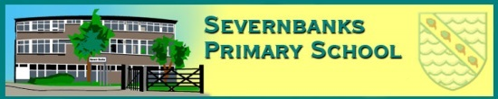


Starlets
Nursery and Pre-School

Dear parents/carers,
We are very excited to introduce two new members of staff to the Starlets nursery team in September.



Miss Pitt currently works in reception class and is a higher level teaching assistant. She has worked at Severnbanks for 6 years in both nursery and reception.
Miss Pitt is trained to support children’s emotional literacy and can deliver communication and language interventions.
Miss Powell is currently reception class teacher and EYFS phase lead.
She already works closely with the Starlets team and is a familiar face in the nursery classroom.
Miss Powell has worked in education for over 20 years, and this will be her 11th year as part of the Severnbanks family.

Should you wish to speak to Miss Powell before the end of the term, please do not hesitate in phoning the office to arrange a visit or telephone conversation.

